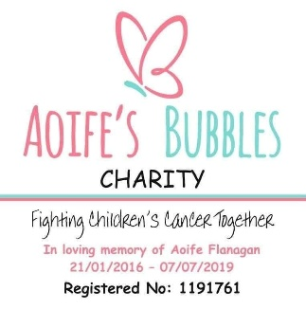
Aoife’s Bubbles Charity

The Bubble Hub Referral Form
Thank you for your interest in referring a child or young person to our new therapy group. This form helps us understand the child’s needs and ensure the group is safe, supportive and appropriate.

1. Referrer Details
- Name:
- Role / Relationship to Child (e.g. parent, healthcare professional, teacher):
- Organisation (if applicable):
- Email Address:
- Telephone Number:

2. Child / Young Person Details
- Child’s Name:
- Date of Birth:
- Age:
- Gender (optional):
- Home Postcode:

3. Medical / Support Information (as relevant)
(Please only share information that is appropriate and necessary.)
- Diagnosis / Reason for Referral:
- Is the child currently undergoing treatment? ☐ Yes ☐ No ☐ Not applicable
- Any additional needs, disabilities or considerations we should be aware of (e.g. mobility, sensory needs, communication):

4. Therapy Group Information
- Why do you feel this group would benefit the child?

- Has the child taken part in group activities before? ☐ Yes ☐ No
If yes, please briefly describe:

5. Parent / Carer Details
- Parent / Carer Name:
- Relationship to Child:
- Email Address:
- Telephone Number:
- Preferred method of contact: ☐ Email ☐ Phone

6. Emergency Contact (if different)
- Name:
- Relationship to Child:
- Telephone Number:

7. Consent & Permissions

Participation Consent
I confirm that I have parental responsibility for the child named above (or am completing this form with the full knowledge and agreement of the person who does) and give permission for my child to be considered for and, if appropriate, take part in the Aoife’s Bubbles Charity therapy group.
Name:
Signature:
Date:

Photography & Feedback Permission (Optional)
Aoife’s Bubbles Charity sometimes takes photographs or short videos during sessions. These are used sensitively and respectfully to help us provide feedback and evidence of impact to our funders and grant makers, which enables us to continue offering free support to children and families.
Any images used will focus on activities rather than clinical information, will never be shared without care, and will not include a child’s full name. We understand that families’ wishes may change, and consent can be withdrawn at any time.
Please indicate your choice below:
- ☐ I give permission for my child to be photographed / filmed for the purposes described above.
- ☐ I do not give permission for my child to be photographed / filmed.
Name:
Signature:
Date:

8. Additional Information
Is there anything else you would like us to know to help support this child, including siblings names and interests if they are coming to The Bubble Hub!

9. Submission
Please return this completed form to:
Aoife’s Bubbles Charity
Email: info@aoifesbubbles.co.uk
If you have any questions, please don’t hesitate to get in touch.
Thank you for helping us support children and families 💛

