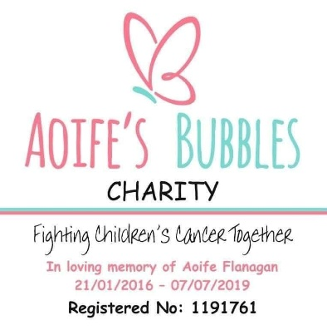
Aoife’s Bubbles Charity

Care Package Referral / Application Form
Thank you for your interest in receiving a care package from Aoife’s Bubbles Charity. Our care packages are thoughtfully created to bring comfort, reassurance and a sense of connection to children affected by cancer.
All information shared with us will be treated confidentially and used solely to help us prepare an appropriate package.

1. Child’s Details
Full Name of Child:
Date of Birth:
Age:
Home Address:
Postcode:
Is the child:
☐ Currently undergoing treatment
☐ Recently completed treatment
☐ Living with long-term effects
☐ A sibling of a child with cancer
☐ Bereaved sibling
☐ Other (please specify):

2. Diagnosis (if applicable)
(Please keep this brief — this helps us tailor the package appropriately.)

3. Hospital / Treatment Centre (if applicable)

4. Parent / Guardian Details
Full Name:
Relationship to Child:
Phone Number:
Email Address:
Preferred method of contact:
☐ Phone
☐ Email

5. Delivery Information
☐ Home delivery
☐ Hospital delivery
☐ Collection (if applicable)
If different from above, please provide delivery name and address:

6. Personalisation (Optional but Helpful)
To help us make the package special, please tell us a little about the child:
- Favourite colours:
- Favourite hobbies/interests:
- Favourite characters/themes (if any):
- Any sensory preferences (e.g. enjoys crafts, likes soft textures, prefers quiet activities, etc.):

7. Allergies / Medical Considerations
(Please list any allergies or items we should avoid.)

8. What Difference Will This Care Package Make?
We would love to understand how this support may help.
(For example: emotional comfort, support during hospital stays, helping a sibling feel recognised, encouragement during treatment, etc.)

9. How Did You Hear About Us?
☐ Hospital / Oncology Team
☐ GP
☐ Social Worker
☐ School
☐ Another Charity
☐ Friend / Family
☐ Social Media
☐ Internet Search
☐ Event
☐ Other (please specify):

10. Consent & Confidentiality
☐ I confirm that the information provided is accurate to the best of my knowledge.
☐ I consent to Aoife’s Bubbles Charity using this information to prepare and deliver a care package.
Signature:
Date:

11. Referral Details (if completed by professional)
Referrer Name:
Role / Organisation:
Contact Details:
☐ I have obtained consent from the parent/guardian to make this referral.

